What Really Drives the Rupee? — Project Plan
Oct 18, 2026 · @Ankit

Project overview
Group 4 will build a data-driven intelligence system that explains and classifies monthly USD/INR movements from January 2010 to the latest available month, using only official published data pulled by code.
Full title: What Really Drives the Rupee? A Data-Driven Intelligence System for Explaining and Predicting USD/INR Movements
Team (Group 4): Ankit Singh (EMBAA25004), Gopalakrishnan S (EMBAA25017), Murugan Perumal (EMBAA25020), Aswin G. (EMBAA25008), Atul Kumar Singh (EMBAA25009), Devanshu Priyam (EMBAA25014)
Business problem. Importers, exporters, treasurers and investors need to know which forces move the rupee and how exposed they are. In 2026 the rupee crossed ₹95 per dollar and became Asia's weakest major currency, so the question is live, not academic.
Research questions
- Which economic and financial variables are most strongly associated with monthly USD/INR returns?
- Is crude oil the dominant driver, or do dollar strength and foreign portfolio flows matter more?
- Does a multi-factor model beat an oil-only model out of sample?
- Can we classify months of high depreciation pressure before they happen, using last month's data?
- Do historical months cluster into distinct currency regimes (calm, oil shock, capital flight)?
- How would the model's estimate change under a chosen what-if scenario?
Benchmark to beat. A 2026 regression by CareEdge chief economist Madan Sabnavis found that three variables explained roughly 25% of the variation in the rupee's daily percentage moves (Polymerupdate summary). Our target is to explain more at monthly frequency and to test which drivers carry the weight.

Data plan
Every variable comes from an official publisher and is downloaded by code; no value is typed in, simulated or interpolated to fill a gap. Twelve of fourteen series download automatically from FRED and the World Bank; FPI flows and recent India CPI need one extra step (scrape or token API) with a manual-CSV fallback.
Sample: January 2012 to the latest common month (the India interest-rate series starts November 2011). That gives roughly 170 monthly rows for modelling. The rupee charts in the dashboard use the full 2010-onward history.
Column | What it measures | Source and ID | Native frequency | Monthly rule | Fetch
USDINR | Rupees per dollar, monthly average | FRED EXINUS (Fed G.5) | Monthly | As published | Auto
USDINR_eom, INR_vol | Month-end rate; volatility of daily returns | FRED DEXINUS | Daily | Last value; SD of daily log returns | Auto
Brent | Brent crude, $/bbl | FRED DCOILBRENTEU (EIA); cross-check World Bank Pink Sheet | Daily / Monthly | Mean | Auto
Broad_USD | Nominal broad dollar index | FRED DTWEXBGS | Daily | Mean | Auto
VIX | Global risk appetite | FRED VIXCLS | Daily | Mean | Auto
US_CPI | US consumer prices | FRED CPIAUCSL | Monthly | As published | Auto
US_Rate, US_10Y | Fed funds; US 10-year yield | FRED FEDFUNDS, GS10 | Monthly | As published | Auto
India_Rate | 3-month interbank rate, % | FRED INDIR3TIB01STM (OECD) | Monthly | As published | Auto
India_CPI | All-India CPI, general, combined | MoSPI CPI API; FRED INDCPIALLMINMEI ends Mar 2025 | Monthly | As published | Token API or CSV
Exports, Imports | Merchandise trade, US$ | FRED XTEXVA01INM667S, XTIMVA01INM667S | Monthly | As published | Auto
Forex_Reserves | Reserves excluding gold, US$ mn | FRED TRESEGINM052N (IMF) | Monthly | As published | Auto
FPI | Net FPI flows, equity + debt | NSDL monthly FPI report | Monthly | As published (US$ toggle) | Scrape or CSV
Live quotes | USD/INR, Brent futures, DXY today | Yahoo Finance via quantmod (INR=X, BZ=F, DX-Y.NYB) | Intraday | Daily close | Auto
Freshness as of 18 Oct 2026: FRED's USD/INR runs to September 2026 (₹95.51 average); reserves and trade run to June 2026; India interbank rate to July 2026. The pipeline trims to the latest month where all model inputs exist and reports the cut-off.
Real-data rules
- No synthetic, simulated or randomly generated values anywhere. If a source fails, the script stops with an error rather than filling in numbers.
- No interpolation of missing months; a missing month is dropped from modelling and listed in the data-quality log.
- Raw downloads are saved untouched in data/raw/ with the download date; cleaned data lives separately in data/processed/.
- A provenance file records source, series ID, URL and download time for every column.
- Manual CSVs (FPI, India CPI) must be copied from the official page and keep the publisher's figures exactly.

Data pipeline
One command runs the chain from download to dashboard, and a weekday refresh keeps it current without anyone retyping a number.
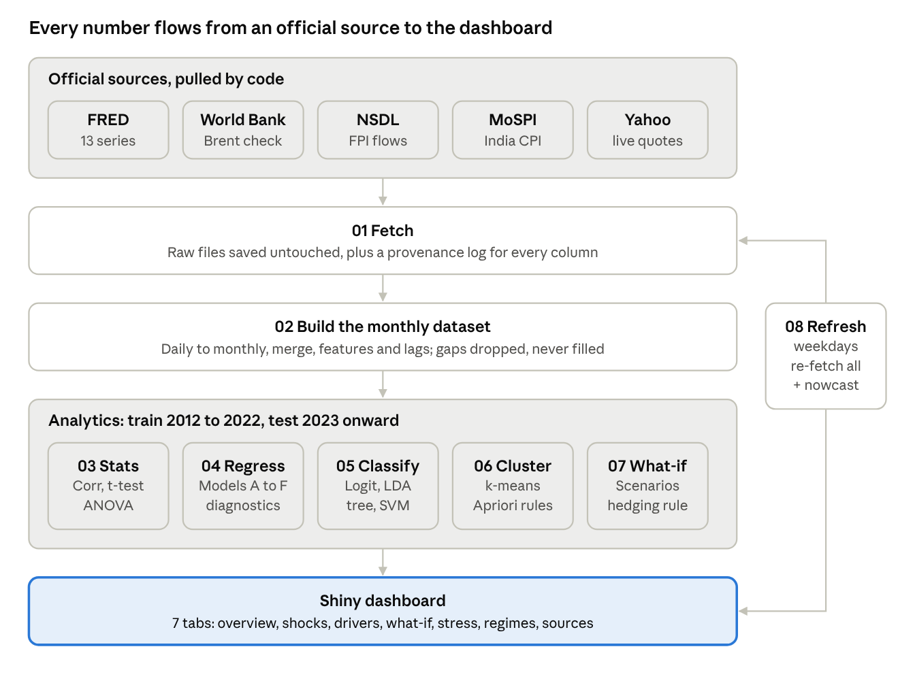
data pipeline · 8 scripts, 5 sources
Daily series become monthly by average (oil, dollar, VIX) or month-end (USD/INR); every predictor also gets a one-month lag so forecasts only use information available at the time.

Analytics plan
The project covers every analytics block in the syllabus (sessions 6–18) on one real dataset. The target is INR_ret, the monthly % change in USD/INR, where a positive value means the rupee weakened. Models train on 2012–2022 and are tested on 2023 onward, split by time, never at random.
Syllabus block (sessions) | Technique | Question it answers | Output
Descriptive (6–7) | Mean, median, SD, skew, frequencies, mode of month type | How often does the rupee weaken, and how much? | Stats table, trend chart with shock bands, histogram
Inferential (8–9) | Correlation with p-values and CIs | Which drivers move with the rupee? | Ranked correlation table, correlogram
Inferential (8–9) | Welch t-tests | Is the rupee weaker in FPI-outflow months? When oil rises? Is volatility higher in shocks? | Test results
Inferential (8–9) | One-way ANOVA, Tukey HSD, Levene, Kruskal-Wallis | Do rupee moves differ across oil and flow regimes? | ANOVA tables, box plots
Predictive (10–11) | Multiple regression, Models A to D | Is oil really the villain, or do dollar and flows matter more? | Model comparison: adj. R², AIC, test RMSE, MAE
Predictive (10–11) | Diagnostics: VIF, Breusch-Pagan, Durbin-Watson, Newey-West SEs | Are the estimates trustworthy? | Diagnostic report, residual plots
Predictive (10–11) | Forecast model F (lagged inputs only) | Can last month's data predict this month? | Honest test vs naive benchmark
Classification (12–14) | Logistic regression, LDA, decision tree, SVM | Can we flag high-depreciation months? | Confusion matrices, sensitivity, AUC
Unsupervised (15–16) | k-means, hierarchical clustering | What currency regimes exist? | Regime profiles, dendrogram
Unsupervised (15–16) | Apriori association rules | Which combinations of conditions co-occur with a weak rupee? | Rules ranked by lift
Prescriptive (17–18) | What-if scenarios with 80% prediction intervals | What happens under oil +20%, dollar +3%, $5 bn outflow? | Scenario table, hedging recommendation
Key definitions
- High-pressure month: depreciation above the 75th percentile of training months. The threshold is fixed on training data so the test period stays unseen.
- Model A: oil only. Model B: oil plus India–US inflation gap. Model C: adds rate-gap change, broad dollar, FPI and trade balance. Model D: adds VIX and last month's FPI, following the lagged-FPI finding in the 2026 regression cited above.
- Early warning vs nowcast: the early-warning classifier uses only last month's data and is the real forecasting test. The nowcast uses same-month drivers and explains rather than predicts. Both are reported and labelled.
RFM analysis (sessions 17–18) does not fit currency data, so the prescriptive block uses scenario analysis and a hedging decision rule instead. We should confirm this substitution with Prof. Varma.

Dashboard plan
The Rupee Intelligence Dashboard is an R Shiny app with seven tabs, built only from files the pipeline produces. It answers three questions fast: what happened to the rupee, what moved with it, and what the model estimates under a changed scenario.
Tab | What the viewer sees | Built from
Overview | Latest USD/INR, live quote, month-to-date estimate, reserves; rupee since 2010 with shock bands | FRED, Yahoo Finance, nowcast
Shock Explorer | Pick an event; rupee, Brent, dollar and reserves indexed to 100 at its start | Monthly dataset, shock list
Driver Scorecard | Standardised effect of each driver with 95% CI; Model A–F comparison | Regression outputs
What-if Simulator | Sliders for oil, dollar, FPI, rate gap, trade, inflation; estimated change, implied USD/INR, 80% range | Model C
Stress Monitor | Monthly probability of high depreciation, actual high months marked, test metrics | Classification outputs
Regimes and Rules | Months coloured by regime; regime profiles; top Apriori rules | Clustering and rules
Data and Sources | Provenance of every column; data-quality log | Provenance file
Shock periods marked: taper tantrum (May–Sep 2013), demonetisation (Nov–Dec 2016), 2018 oil spike and EM sell-off, COVID-19 (Feb–May 2020), Russia–Ukraine war and Fed hikes (2022), and the 2026 West Asia conflict when the rupee passed ₹95.
To share it, deploy free on shinyapps.io with rsconnect::deployApp().

Code structure
The code is ten R scripts plus a Shiny app; source("R/run_all.R") runs the whole pipeline end to end from the project folder.
Script | What it does | Main outputs
00_config.R | Packages, folders, dates, FRED series catalogue, shock list | —
01_fetch_data.R | Downloads 13 FRED series (API with key, or public CSV), World Bank Brent, NSDL FPI (scrape or CSV), India CPI (MoSPI API or CSV) | data/raw/*, provenance.csv
02_build_dataset.R | Daily to monthly, merge, features, 1-month lags, high-pressure label, QA log | rupee_monthly.csv, model_data.csv
03_descriptive_inferential.R | Descriptives, correlations, t-tests, ANOVA | Stats tables, 4 charts
04_regression.R | Models A–D and F, diagnostics, out-of-sample test, scorecard | model_comparison.csv, driver_scorecard.csv
05_classification.R | Logistic, LDA, tree, SVM for early warning and nowcast | classification_results.csv, tree plots
06_clustering_rules.R | k-means, hierarchical, Apriori | Regime profiles, rules
07_scenario.R | What-if scenarios and hedging decision rule | scenarios.csv, hedging_decision.csv
08_realtime_refresh.R | Live quotes, re-download, month-to-date nowcast | data/live/*
app.R | Shiny dashboard | Interactive app
Real-time data. Most series refresh automatically from official APIs. FRED daily series lag about a week, so the live ticker uses Yahoo Finance quotes through quantmod; the model nowcast stays on FRED daily data so its inputs match the training definitions. Schedule 08_realtime_refresh.R on weekdays with cron or Windows Task Scheduler (steps in the README).
Setup. Install R 4.1+, open the project folder, optionally add a free FRED API key to ~/.Renviron, then run run_all.R. The first run installs missing packages.

Timeline and team roles
The work runs in six weekly phases, and nothing downstream starts until the dataset is frozen with full provenance. Week numbers count from kickoff; map them to the course calendar once the submission date is confirmed.
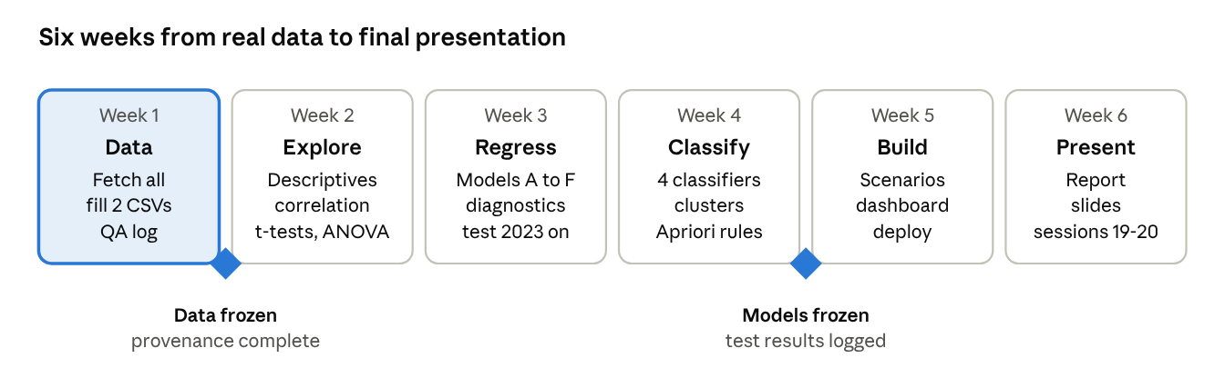
project roadmap · 6 weeks, 2 gates
Suggested split, one workstream per member; edit the owners as the group agrees.
Workstream | Scripts | Suggested owner
Data collection, manual CSVs, provenance | 01, 02 | Ankit Singh
Descriptive and inferential analysis | 03 | Gopalakrishnan S
Regression models and diagnostics | 04 | Murugan Perumal
Classification and stress monitor | 05 | Aswin G.
Clustering, rules and scenarios | 06, 07 | Atul Kumar Singh
Dashboard, live refresh, report and slides | 08, app.R | Devanshu Priyam

Sources
- FRED: Indian Rupees to U.S. Dollar Spot Exchange Rate (EXINUS)
- FRED: India 3-month interbank rate (INDIR3TIB01STM)
- FRED: India total reserves excluding gold (TRESEGINM052N)
- FRED: India merchandise exports (XTEXVA01INM667S)
- FRED: India CPI (INDCPIALLMINMEI)
- World Bank Commodities Price Data (Pink Sheet)
- NSDL Monthly FPI Net Investments
- MoSPI CPI API user manual
- Polymerupdate: Rupee@97, decoding the drivers of the slide
- Economic Times, "Explained: What really drives the rupee" (provided by the group; not reachable from this workspace)

Risks and limitations
The biggest risks are two semi-manual series and the temptation to over-claim; each has a fallback that keeps the data real.
Risk | Impact | Mitigation
NSDL page layout blocks the scraper | No FPI data | Copy the NSDL monthly table into fpi_monthly.csv exactly as published
FRED India CPI ends Mar 2025 | Inflation gap missing for recent months; sample shrinks | Add MoSPI headline CPI (about 18 months) to india_cpi.csv, or use the MoSPI API
World Bank Pink Sheet URL changes yearly | Oil cross-check fails | Brent from FRED/EIA is primary; update the URL in config
Trade and reserves lag about 3 months | Model sample ends mid-2026 | Pipeline reports the cut-off; dashboard rupee chart still runs to the latest month
RBI intervention is not in the data directly | Unexplained variation, especially in 2026 | Use reserve changes as a proxy and state it as a limitation
Monthly averages smooth daily shocks | Lower apparent volatility | Also report month-end returns and daily volatility
Results read as causation | Misleading conclusions | Describe results as associations; Newey-West SEs; out-of-sample tests
Same-month drivers used for forecasting | Overstated accuracy | Separate early-warning (lagged) and nowcast models
Integrity rules for the group
- No team member types, estimates or fills a data value. Every number traces to provenance.csv.
- Cite FRED, the World Bank, NSDL, MoSPI and any articles in APA style, per the course plagiarism policy.
- Report weak results honestly; a model that fails to beat the naive benchmark is a finding, not a failure.

